
e-comerce sale analysis
Analysis in using DAX and Data Visualization


Assignment Description :
  - This project focuses on analysis sales performance using Microsoft Power BI. The report uses sales-related datasets, including Order Details, List of Orders, and Sales Target, to understand sales trends and business performance.
Column :
Column name | Description
Order id | Provides order id
Order date | Provides order date
Customer name | Provides customer name
City | Provides city for location
Category | Provides category
State | Provides state name
Amount | Provides amount
Profit | Analysis the profit
Location | Provides location
Profit margin | Profit margins
Profit status | Provides profit status
Month of order | Provides month of order
Target | Month target

1.Tranforming data:
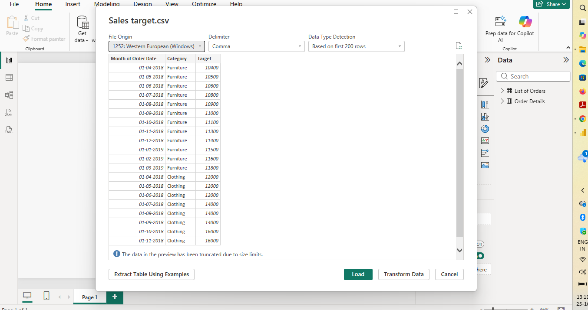
2 Create a Calculated Column for 'Category Type':
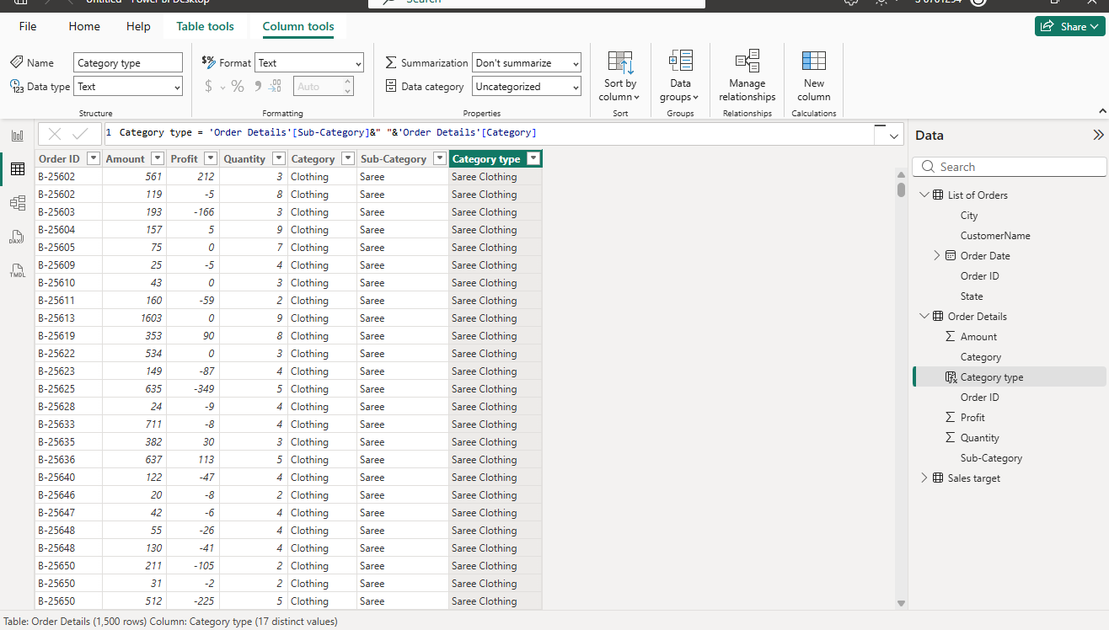

3 Calculate Revenue per Order in Order Details Table:
Order details = 'Order Details'[Amount]*'Order Details'[Quantity]
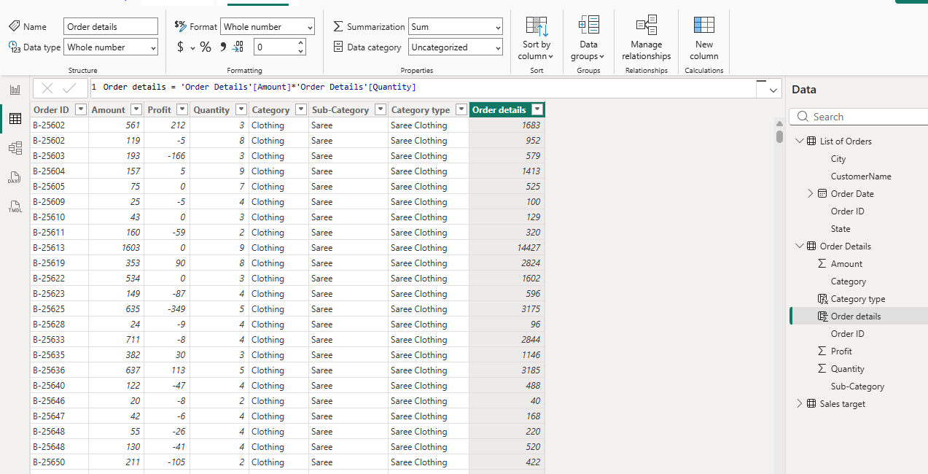

4 Create a Calculated Column to Categorize Sales:
sale catgory = if('Order Details'[Amount]>AVERAGE('Order Details'[Amount]),"below average","above average")
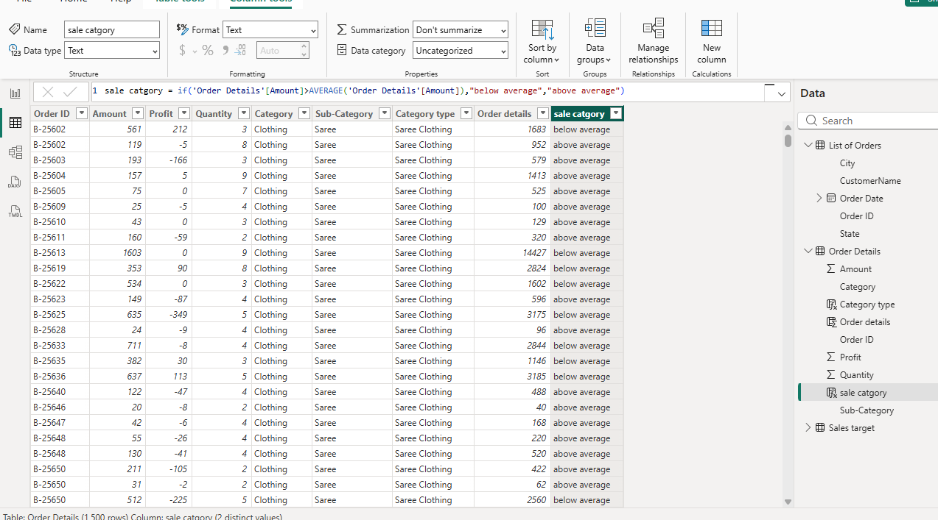Calculated Measures:
Order count and average profit in Delhi and YTD
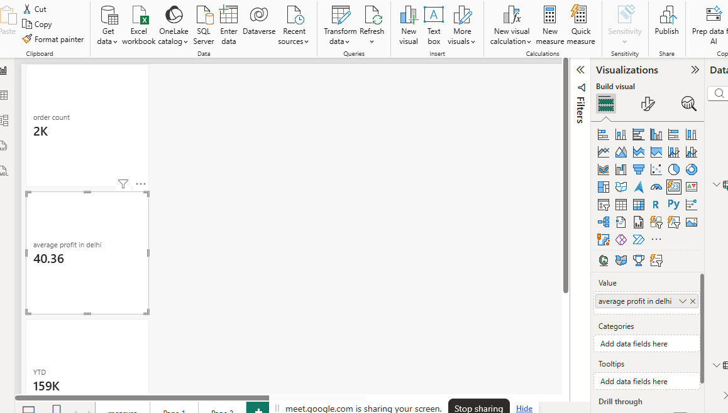
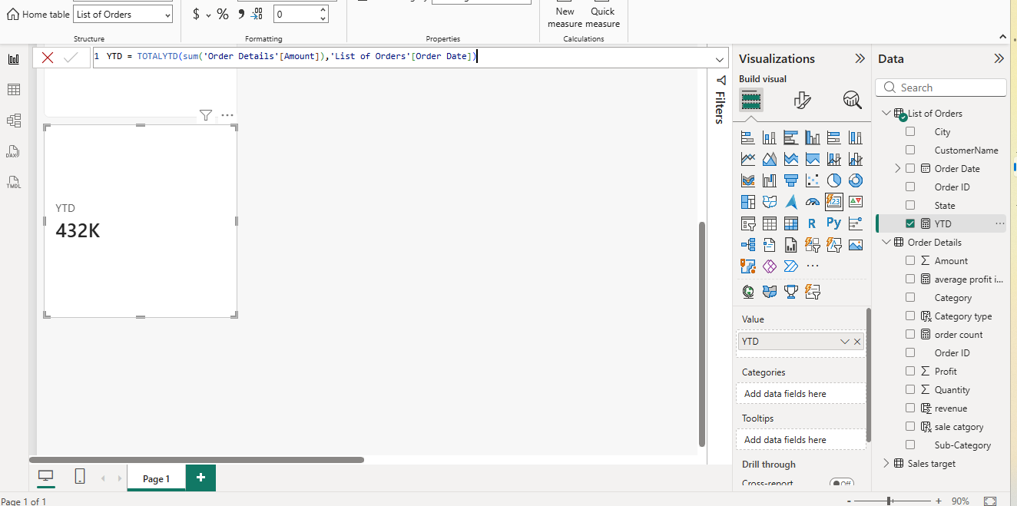

YTD = TOTALYTD(sum('Order Details'[Amount]),'List of Orders'[Order Date])
average profit in delhi = CALCULATE(AVERAGE('Order Details'[Profit]), 'List of Orders'[State]="Delhi")
order count = COUNT('Order Details'[Order ID])
Data Visualization:
Sales Target Achievement by Category:
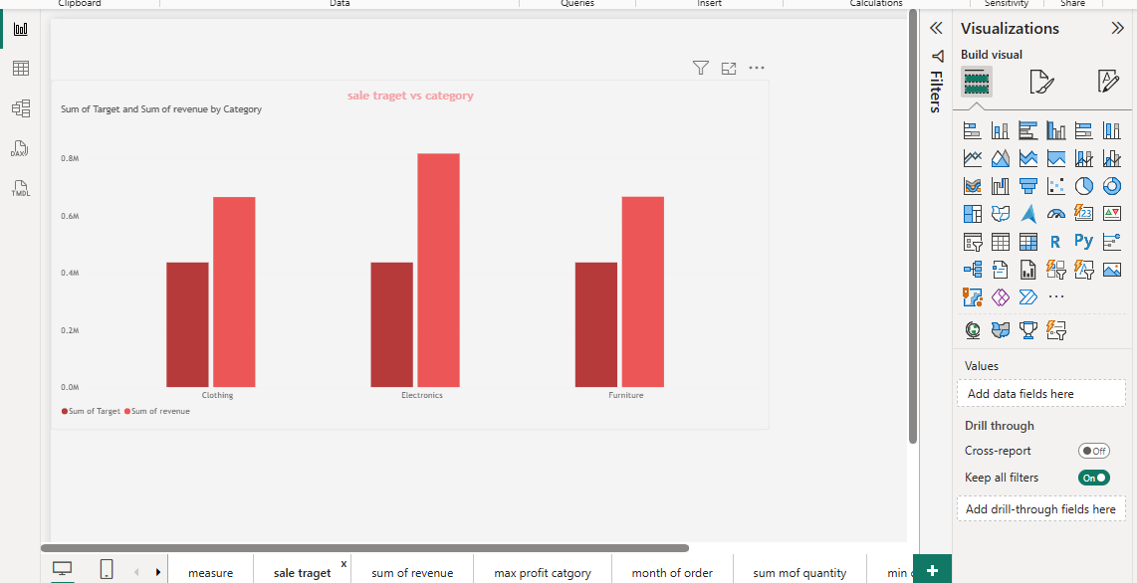
Max Profit Margin by Sub-Category:
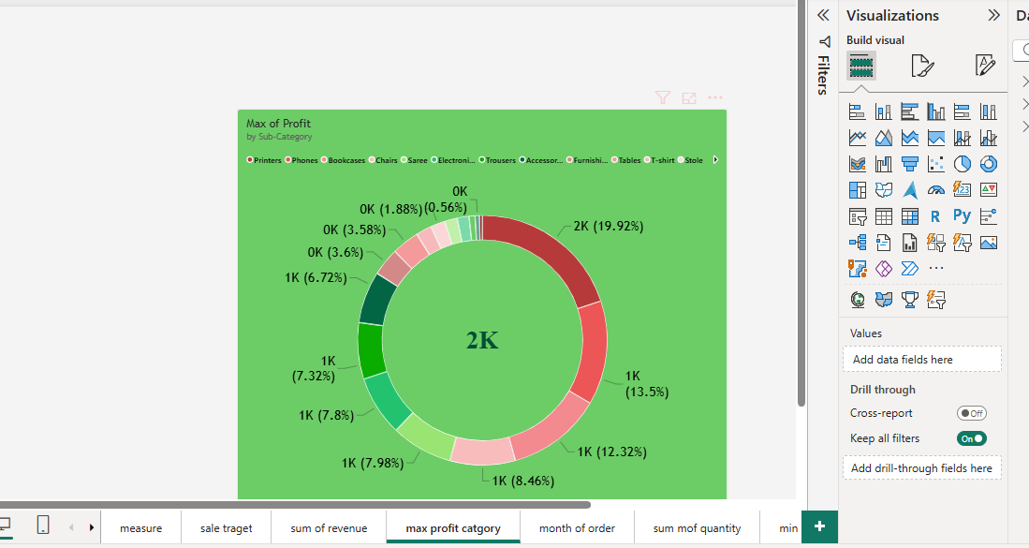
Monthly Sales Trend:
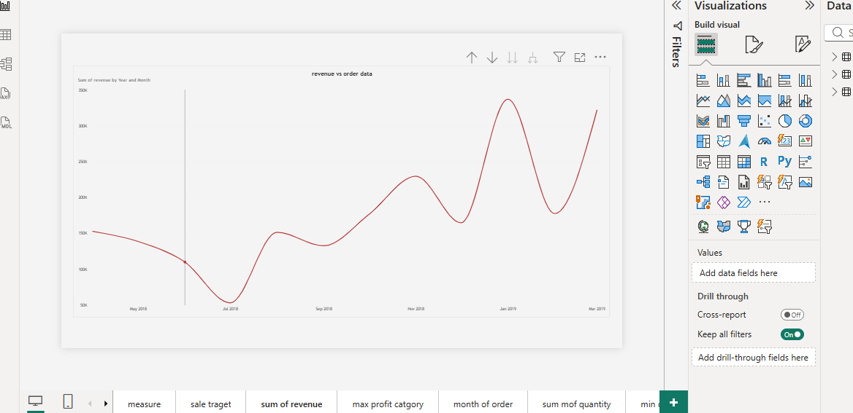
Comparison of Profit and Quantity by Sub-Category:
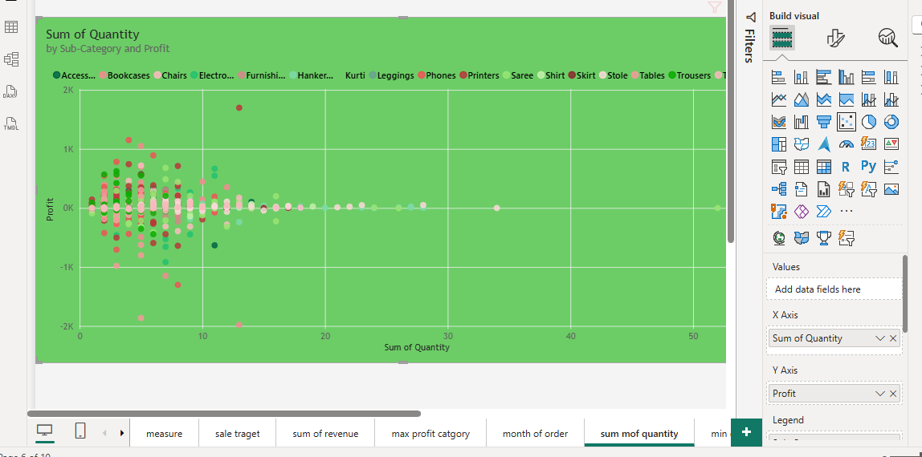

Comparison of Total Sales Amount and Target:
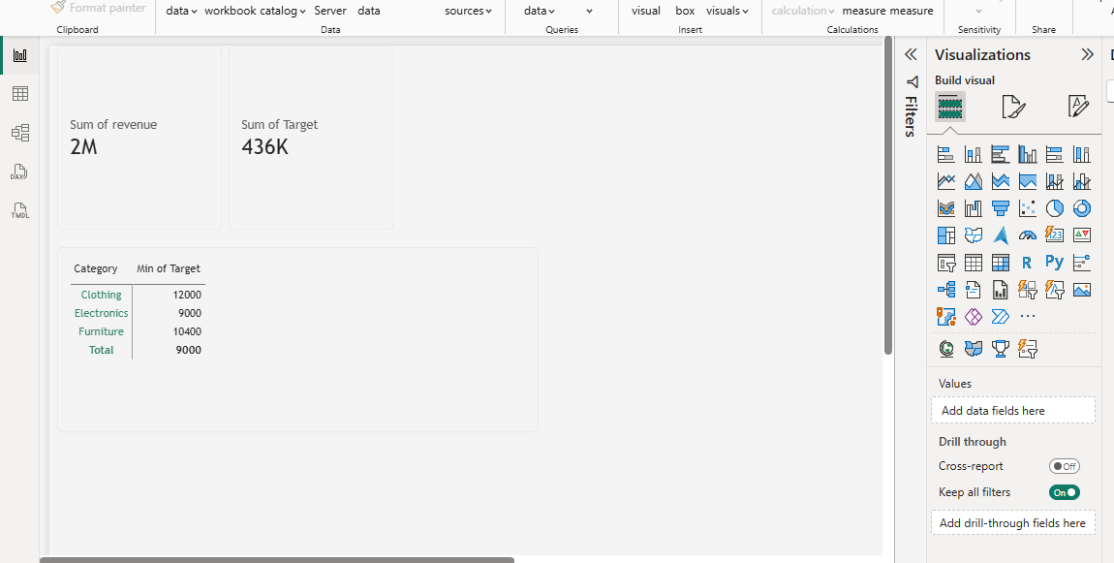

Sales Performance Matrix:
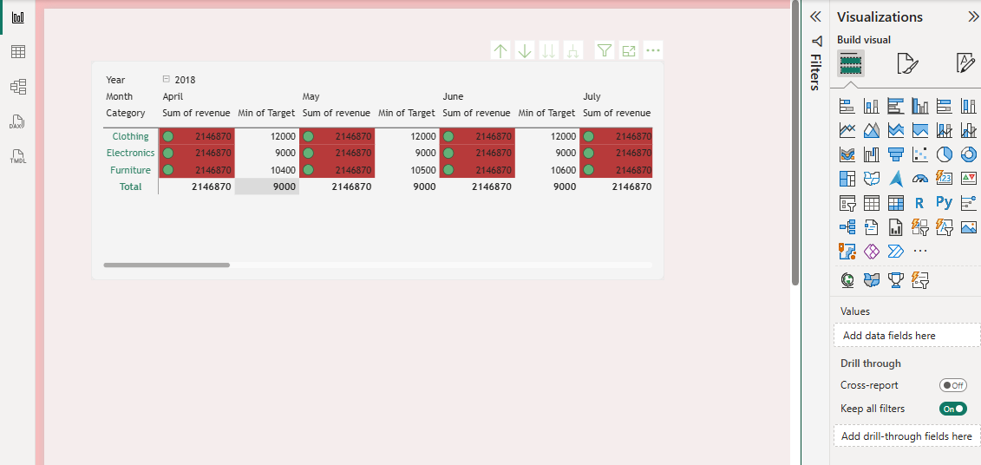
Geographic Sales Analysis:
Not working my power bi
Sales Distribution by Sub-Category:
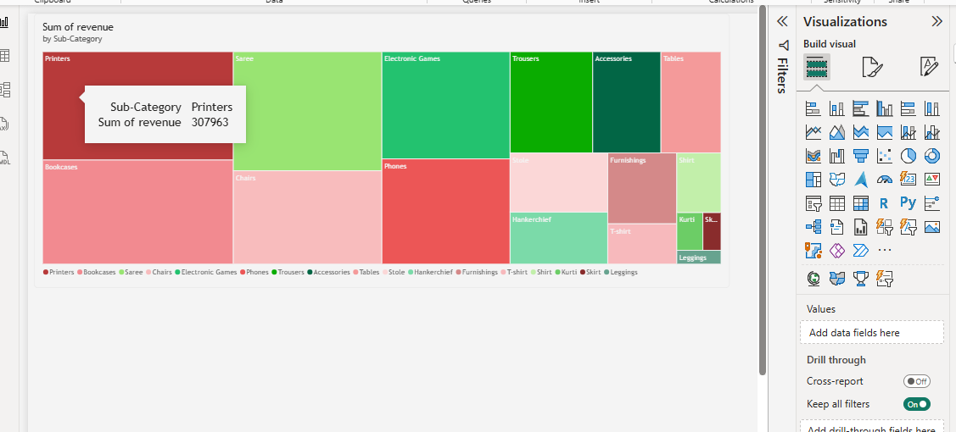
Order Count Analysis by State:]

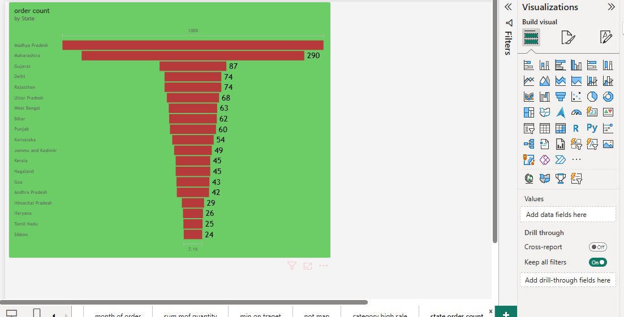
Thank you mam

